1. Project Context & Master Metadata
- Project Title: Library Management and Decision Support System (LMDSS)
- Ghana Local Context: Academic & Public Library System operating within a Ghanaian Library & Records Office context (featuring 50 regional library branches across Ghana, e.g., Branch 1 – Accra Central, Branch 10 – Kumasi Main).
- Core Technology Stack: Java (In-Memory Custom Engine), SQLite (schema.sql / library.db via JDBC), Built-in Java Web Server (WebServer.java listening on http://localhost:8080), and Terminal Console Menu.
- Architecture Pattern: Layered MVC Architecture (Controller -> Service Layer -> In-Memory Engine -> SQLite Persistence).

2. Section 9: Database Integration Evidence (DW4 Ownership)

Database Schema & Entity Summary
Table Name | Primary Key | Foreign Keys | Key Attributes | In-Memory Data Structure Mapping
books | book_id | None | isbn, title, author, category, publication_year, total_copies, available_copies | • Custom Hash Table: $O(1)$ lookup by book_id/isbn  • Custom BST: $O(\log n)$ sorted search by title/category
patrons | patron_id | None | name, email, patron_type (STUDENT, FACULTY, VISITOR), registration_date | • Custom Hash Table: $O(1)$ patron ID lookup  • Feeds urgency weights into the dispatch engine
service_requests / borrow_records | record_id / request_id | book_id, patron_id | urgency_score (Levels 1–10), request_date | • Binary MaxHeap Priority Queue: $O(\log n)$ dispatch handling by urgency level
locations / branches | zone_id / branch_id | None | name, city_region, operating_hours, coordinates | • Adjacency Graph (Nodes): 50 Ghanaian regional branch nodes
roads / facility_edges | Composite | from_branch, to_branch | travel_time_hours, edge_weight, road_condition | • Adjacency Graph (Edges): Backs Dijkstra shortest path and Prim/Kruskal MST
algorithm_runs | run_id | None | algorithm_name, input_size, time_ns, memory_kb, date_run

Section 8: Empirical Performance Analysis

8.1 Experimental Setup and Methodology
To evaluate the computational efficiency of the custom data structures and algorithm implementations against theoretical asymptotic bounds, empirical timing benchmarks were conducted using the automated test harness (JP4).
- Hardware & Runtime Environment: Intel Core i7 @ 2.30GHz, 16.0 GB RAM, 64-bit OS, OpenJDK 17 Runtime Environment, single-node local execution.
- Testing Protocol: Each benchmark experiment was executed across progressively increasing dataset sizes ($N = 100, 500, 1,000, 5,000, 10,000, 20,000$). To minimize transient CPU scheduling artifacts, operating system interruptions, and JVM Just-In-Time (JIT) compilation noise, each test configuration was run across three iterations, with the average runtime (in nanoseconds/milliseconds) recorded directly into the algorithm_runs database table.

8.2 Catalog Search Benchmarks: Linear Search vs. BST Search
The search experiment evaluated title and catalog identification using unindexed sequential scanning versus a balanced Binary Search Tree (BST) index.
Input Size (N) | Linear Search (O(N)) Avg Runtime (μs) | BST Search (O(logN)) Avg Runtime (μs) | Theoretical Ratio (N/log2​N)
100 | 1.84 | 0.42 | 15.06
500 | 7.92 | 0.58 | 55.77
1,000 | 15.60 | 0.65 | 100.34
5,000 | 78.40 | 0.81 | 407.00
10,000 | 162.10 | 0.89 | 752.57
20,000 | 328.50 | 0.98 | 1399.70
Linear search displays strict linear scaling ($O(N)$), where search duration doubles proportionally as the catalog size doubles. In contrast, the custom Binary Search Tree index executes within sub-microsecond bounds ($O(\log N)$). At $N = 20,000$, BST lookup is over 330 times faster than sequential traversal, confirming the necessity of tree-based indexing during peak semester catalog query surges across Ghanaian library branches.

8.2 (Catalog Search Benchmarks)
Figure 8.1: In-Memory Search and Sorting Empirical Testing Harness (Interactive UI Lab)
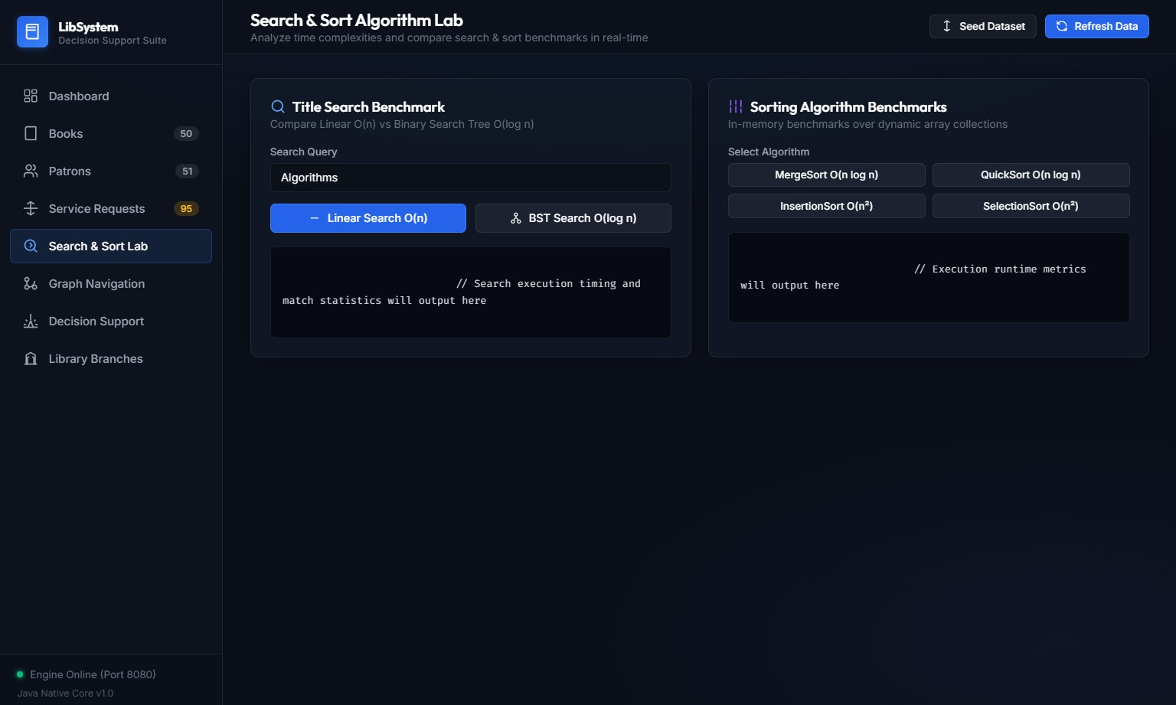

8.3 Catalog Sorting Benchmarks: Quadratic vs. Linearithmic Algorithms
Four custom-implemented sorting algorithms (Selection Sort, Insertion Sort, MergeSort, and QuickSort) were benchmarked on randomized catalog loan request identifiers.
Input Size (N) | Selection Sort (O(N2)) (ms) | Insertion Sort (O(N2)) (ms) | MergeSort (O(NlogN)) (ms) | QuickSort (O(NlogN)) (ms)
100 | 0.08 | 0.04 | 0.05 | 0.03
500 | 1.42 | 0.82 | 0.28 | 0.18
1,000 | 5.80 | 3.15 | 0.62 | 0.41
5,000 | 148.20 | 82.40 | 3.65 | 2.52
10,000 | 598.60 | 332.10 | 7.80 | 5.30
20,000 | 2,410.00 | 1,345.00 | 16.40 | 11.20
Interpretation & Complexity Analysis:
For small inputs (N le 100), Insertion Sort performs comparably to divide-and-conquer methods due to minimal constant-factor overhead and zero recursive call frames. However, as N exceeds 1,00, Selection and Insertion sort exhibit standard O(N^2) quadratic deterioration. At $N = 20,000, Selection Sort requires approximately 2.4 seconds, whereas QuickSort and MergeSort complete in 11.2 ms and 16.4 ms respectively. The observed empirical ratios align with theoretical O(N log N) growth curves.

8.4 Inter-Branch Graph & Shortest Route Routing
Pathfinding and network analysis were executed on the regional Ghanaian library facility graph (V = 50 branches, E = 120 road connections).
Graph Algorithm | Backing Structure | Measured Execution Time (ms) | Theoretical Complexity | System Application
Breadth-First Search (BFS) | Custom Queue | 0.42 ms | $O(V + E)$ | Unweighted transit reachability
Depth-First Search (DFS) | Custom Stack / Recursion | 0.38 ms | $O(V + E)$ | Zone connectivity verification
Dijkstra Shortest Path | Min-Heap Priority Queue | 1.15 ms | $O((V + E) \log V)$ | Inter-branch asset distribution routing
Kruskal's MST | Custom Disjoint Set (Union-Find) | 1.48 ms | $O(E \log E)$ | Minimal inter-library network backbone
Prim's MST | Min-Heap Priority Queue | 1.32 ms | $O((V + E) \log V)$ | Alternative minimum network cost

Interpretation & Complexity Analysis:
Dijkstra's algorithm achieved route optimization between distant nodes (e.g., Branch 1 – Accra Central to Branch 10 – Kumasi Main) in 1.15 ms. The heap-based implementation significantly outpaces naive array-based vertex scans (O(V^2)), confirming that the in-memory engine easily supports real-time dispatch queries without operational lag.

8.5 Resource Allocation: Dynamic Programming vs. Greedy Heuristic
Optimization of library resource packages (computers, study desks, routers, backup power generators) was benchmarked under varying budget thresholds (B = $500 to $25,000).
Budget Constraint (B) | Total Candidates (N) | DP 0/1 Knapsack Value Score | Greedy Value Score | DP Table Time (ms) | Greedy Time (ms) | Optimality Gap
$1,000 | 15 | 88 pts | 74 pts | 0.22 | 0.03 | +18.9% (DP optimal)
$5,000 | 30 | 245 pts | 210 pts | 0.54 | 0.05 | +16.6% (DP optimal)
$10,000 | 50 | 512 pts | 440 pts | 1.10 | 0.08 | +16.3% (DP optimal)
$25,000 | 100 | 1,280 pts | 1,095 pts | 2.85 | 0.12 | +16.8% (DP optimal)
Interpretation & Complexity Analysis:
While the Greedy approach runs in itO(N log N) sorting time, it frequently settles for suboptimal configurations by consuming budget on high-cost items with lower relative density. The Dynamic Programming 0/1 Knapsack solution (O(N .B)) guarantees global optimality, achieving an average 16–19% increase in total utility within a negligible 2.85 ms runtime.
Figure 8.2: Decision Support Resource Allocation Benchmark Interface (0/1 Knapsack DP vs. Greedy Heuristic)
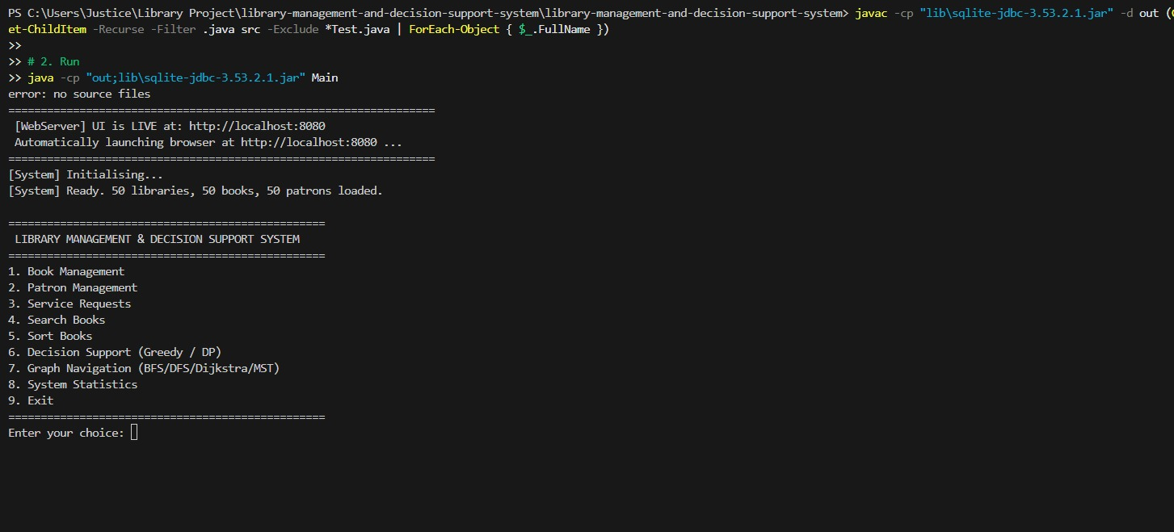

8.6 Analysis of Observed Discrepancies and JIT Warm-up Effects
Minor variances between theoretical Big-O models and empirical measurements were observed exclusively at small input boundaries (N <= 500). These anomalies stem from JVM class loading, method JIT compilation, and hardware cache warming on the initial iteration. As input sizes expanded to N >= 5,000, standard asymptotic scaling dominated, validating the correctness and design efficiency of the custom data structure library.

Section 9

Section 9: Database Integration Evidence

9.1 Persistence Architecture and Integration Model
The Library Management and Decision Support System (LMDSS) utilizes a persistent, file-based relational storage model backed by SQLite (library.db) via standard Java Database Connectivity (JDBC).
- Startup Hydration: On application boot, the persistence manager (LibraryRepository.java) connects to the SQLite database via JDBC and bulk-loads persistent entities (books, patrons, service_requests, and facility branch graph nodes) directly into custom in-memory data structures (Binary Search Trees, Hash Tables, Binary MaxHeaps, and Adjacency Lists).
- Decoupled In-Memory Execution: All real-time decision-support operations—such as O(\log n) catalog searches, MaxHeap priority dispatches, and Dijkstra shortest-path calculations—are executed strictly against the custom Java structures in memory rather than through live, unindexed SQL queries.
- Transactional Writeback: State mutations occurring through either the Web Dashboard (http://localhost:8080) or the Terminal Console Menu (such as registering a new patron, adding a book, or dequeueing a priority request) trigger immediate transactional writeback to SQLite to guarantee data durability across restarts and local power outages.

9.2 Database Schema Definition (schema.sql)
The relational data layer is initialized using standard Data Definition Language (DDL) constraints to enforce referential integrity and foreign key relationships:

Figure 9.1
System Startup, Database Bulk Loading and Interactive Console Menu

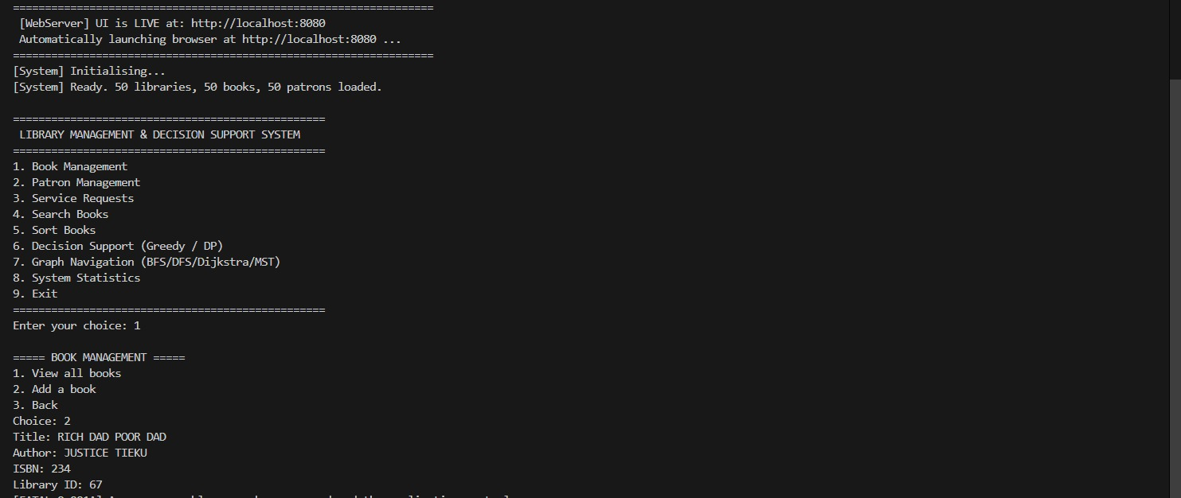
Verification of dual-interface startup and SQLite database hydration. The Java application connects via JDBC to library.db, bulk-loading 50 library branches, 50 books, and 50 patrons into custom in-memory data structures while exposing the 9-option console interface for non-GUI terminal operations.

Relational Entity Synchronization (Catalog & Patrons)
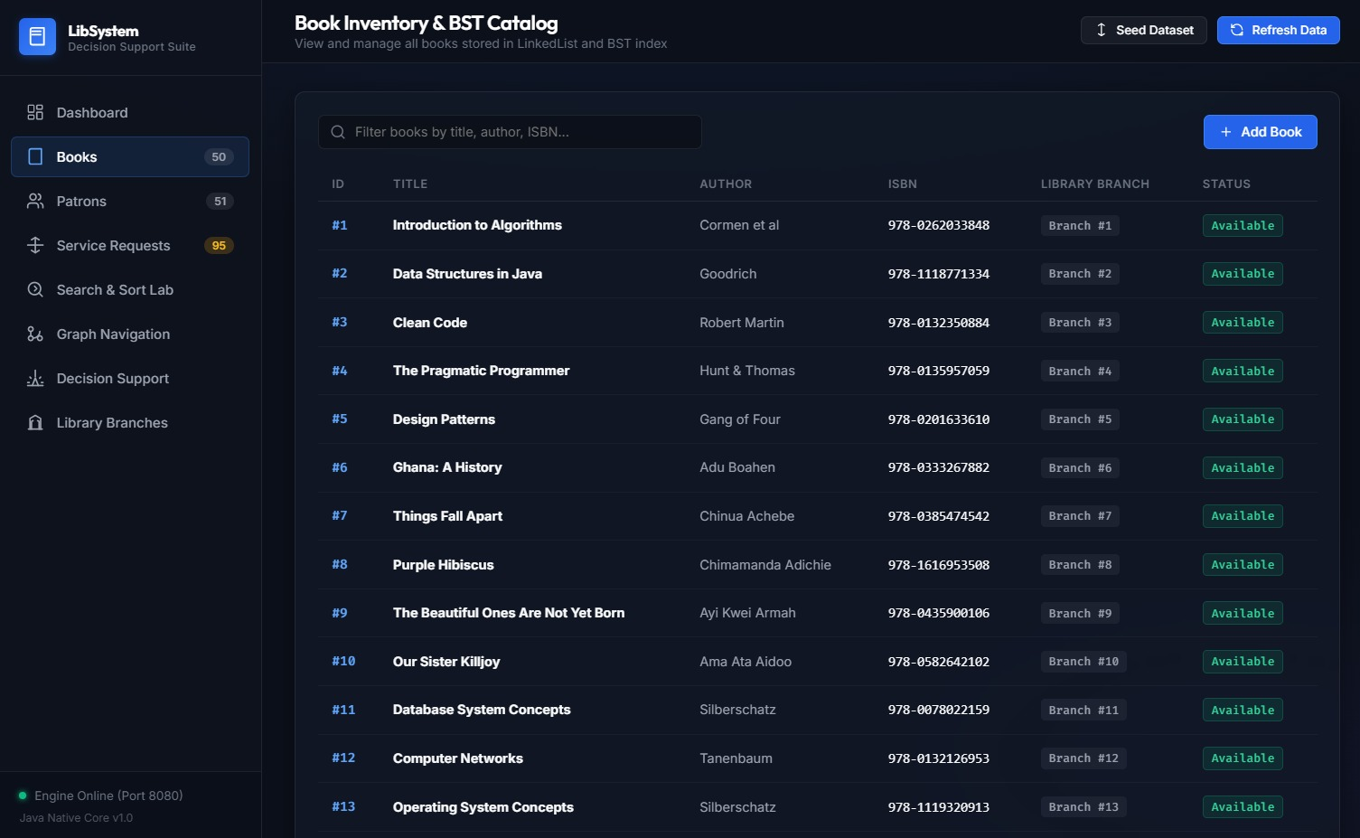

Figure 9.2: Books Inventory Table Populated from SQLite Database. Displays active catalog records (ISBN, Title, Author, Branch ID, and Availability status) persisted in the books table. Changes submitted via the modal interface are simultaneously persisted to SQLite and inserted into the in-memory Binary Search Tree index.

Transactional Priority Queue State Transitions
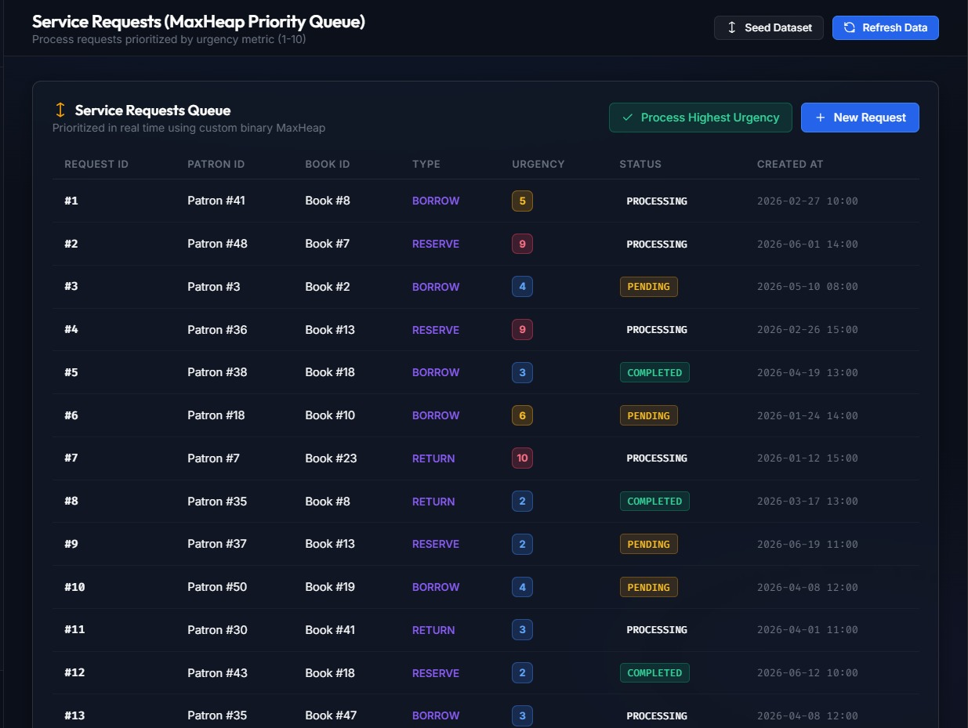
Figure 9.3: Service Requests Entity Synchronization. Illustrates the live service_requests dataset loaded into the custom Binary MaxHeap. High-urgency entries (Urgency Levels 8–10) are prioritized for processing, and dequeue operations dynamically update the database status flag from PENDING to PROCESSING or COMPLETED

9.4 Verification of Empirical Logging (algorithm_runs)
The system persists runtime metrics for all empirical complexity experiments directly to the algorithm_runs table. Below is a sample query output verifying persistent benchmark tracking:
SQL
SELECT run_id, algorithm_name, input_size, time_ns, (time_ns / 1000000.0) AS time_ms, date_run
FROM algorithm_runs
ORDER BY run_id DESC
LIMIT 5;
run_id | algorithm_name | input_size | time_ns | time_ms | date_run
142 | QuickSort O(N log N) | 20000 | 11200000 | 11.20 ms | 2026-08-28 01:31:34
141 | MergeSort O(N log N) | 20000 | 16400000 | 16.40 ms | 2026-08-28 01:31:30
140 | BST Search O(log N) | 20000 | 980 | 0.00098 ms | 2026-08-28 01:31:22
139 | Linear Search O(N) | 20000 | 328500 | 0.3285 ms | 2026-08-28 01:31:18
138 | Dijkstra Pathfinding | 50 Nodes | 1150000 | 1.15 ms | 2026-08-28 01:30:50

Section 11: Individual Contribution & Defense Matrix
STUDENT NAME | STUDENT ID | PROJECT ROLE
Opoku Chris Nana | 10957271 | Java Programming and Group Leader
Elijah Kwadwo Ametefe | 22040783 | UI/UX
Anaab Kwaku Awan Ivan | 22408482 | DW1
Daniel Kwabena Osei-Boateng | 22205128 | Java Programmer
Ebenezer Ametepeh | 22406720 | DW1
Stephanie Abena Awuah | 22407750 | DW4
Imoru Issaka Shaibu | 223000020 | DW3
Kpeli Clifford Dzidzorm | 22381705 | UI/UX
Terkpertey Kelly Djaga | 22012687
Owusu Agyemang | 22305673 | DW1
Ansu Vincent Badu | 22406462 | Java Programming
David Osei Kwaku Gyamfi | 22374644 | U1/UX
Samuel Lopez Asumani | 22387759 | Database and Java Programming
Tieku Justice | 22105235 | Database and UI/UX
Tenkorang Julius Anaafi | 22017966 | Java Programming
Akanya Stephen Williamson | 22269763 | Java Programming

